Read the text and fill in the table on the text!
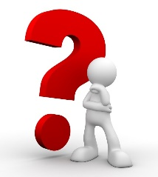 | I had a question, I didn't understand...
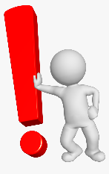 | An excerpt in the text that surprised me, or seems very important...
 | My favorite passage in the text....
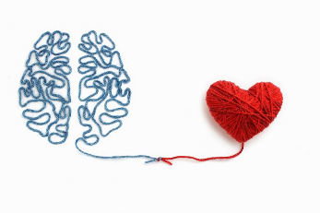 | This story reminded me....
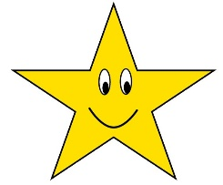 | The main idea of the story...
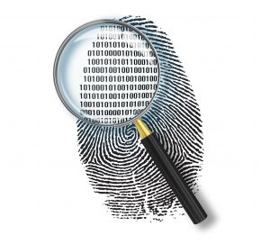 | Proof – a fragment confirming the main idea of the story.

