[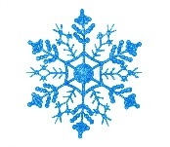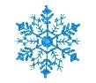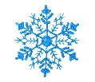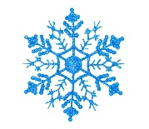](https://www.google.lv/url?sa=i&url=https%3A%2F%2Fwww.dreamstime.com%2Fstock-photo-shiny-blue-snowflake-white-background-image42833113&psig=AOvVaw3JMsw9yg84K6PIdZoZxUaI&ust=1608229880312000&source=images&cd=vfe&ved=0CAIQjRxqGAoTCMi5h6yR0-0CFQAAAAAdAAAAABCOAQ) Winter holiday reading challenge

[Shiny blue snowflake stock image. Image of decor, cold - 42833113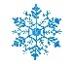Shiny blue snowflake stock image. Image of decor, cold - 42833113](https://www.google.lv/url?sa=i&url=https%3A%2F%2Fwww.dreamstime.com%2Fstock-photo-shiny-blue-snowflake-white-background-image42833113&psig=AOvVaw3JMsw9yg84K6PIdZoZxUaI&ust=1608229880312000&source=images&cd=vfe&ved=0CAIQjRxqGAoTCMi5h6yR0-0CFQAAAAAdAAAAABCOAQ) Who will read more pages - teacher or the whole class together***?***

|  |  |  |  |
| --- | --- | --- | --- |
| ***Date*** | ***Authors*** | ***Book title*** | ***Number of pages you read*** |
|  |  |  |  |
|  |  |  |  |
|  |  |  |  |
|  |  |  |  |
|  |  |  |  |
|  |  |  |  |
|  |  |  |  |
|  |  |  |  |
|  |  |  |  |
|  |  |  |  |
|  |  |  |  |

[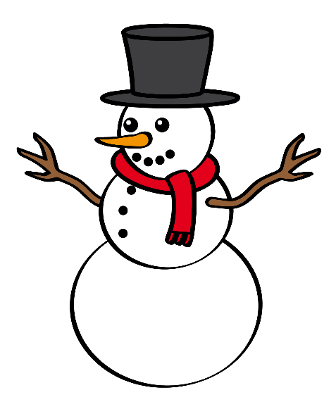](https://www.google.lv/url?sa=i&url=https%3A%2F%2Fwww.pinterest.com%2Fpin%2F51580358212704055%2F&psig=AOvVaw2R9sv4dluNbTLhcbEalt8A&ust=1608229084662000&source=images&cd=vfe&ved=0CAIQjRxqGAoTCLiptK2O0-0CFQAAAAAdAAAAABDTAQ)

[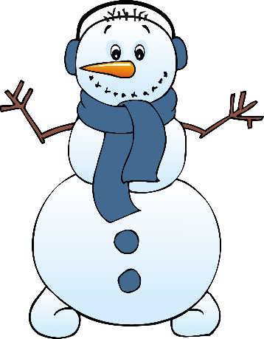](https://www.google.lv/url?sa=i&url=https%3A%2F%2Fclipartion.com%2Ffree-clipart-2217%2F&psig=AOvVaw2R9sv4dluNbTLhcbEalt8A&ust=1608229084662000&source=images&cd=vfe&ved=0CAIQjRxqGAoTCLiptK2O0-0CFQAAAAAdAAAAABCMAQ)[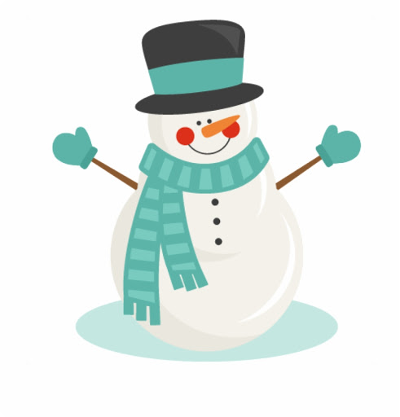](https://www.google.lv/url?sa=i&url=http%3A%2F%2Fclipart-library.com%2Ffree%2Fsnowman-clipart-transparent-background.html&psig=AOvVaw2R9sv4dluNbTLhcbEalt8A&ust=1608229084662000&source=images&cd=vfe&ved=0CAIQjRxqFwoTCLiptK2O0-0CFQAAAAAdAAAAABBx)